#Reachability Analysis in a Graph Using NetworkX
import networkx as nx
import matplotlib.pyplot as plt
G=nx.Graph()
G.add_edges_from([
("A","B"),
("B","C")
])

G.add_edge("D","E")
print("is A reachable from E ?",nx.has_path(G,"A","E"))
print("is B reachable from C ?",nx.has_path(G,"B","C"))
print("is D reachable from E ?",nx.has_path(G,"D","E"))
print("is A reachable from C ?",nx.has_path(G,"A","C"))
print("is D reachable from B ?",nx.has_path(G,"D","B"))
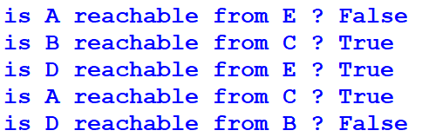

pos=nx.spring_layout(G)
nx.draw(G,pos,with_labels=True,node_color='lightblue',node_size=1500)
plt.title("Graph with less reachability(Disconnected Components )")
plt.show()

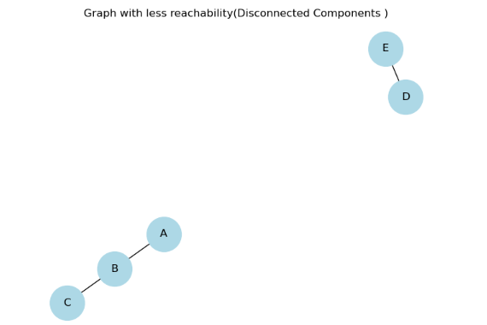

# Degree Distribution and User Connectivity Analysis in a Social Network
import networkx as nx
import matplotlib.pyplot as plt
import pandas as pd

df = pd.DataFrame({
'User1': ['Alice', 'Alice', 'Alice', 'Bob', 'Bob', 'Charlie', 'David', 'Eva', 'Frank', 'Grace', 'Harry', 'David'],
'User2': ['Bob', 'Charlie', 'David', 'Charlie', 'Eva', 'Frank', 'Grace', 'Harry', 'Alice', 'Grace', 'Frank', 'Eva']
})
display(df)
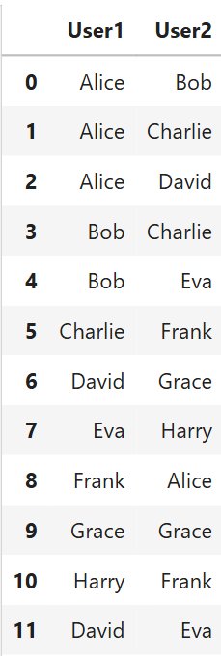

G = nx.from_pandas_edgelist(df, 'User1', 'User2')
nodes = G.number_of_nodes()
edges = G.number_of_edges()
degrees = dict(G.degree())
highest_node = max(degrees, key=degrees.get)
lowest_node = min(degrees, key=degrees.get)

print("=" * 60)
print("Social Media Friendship Network Dashboard")
print("=" * 60)
print(f"Total Users: {nodes}")
print(f"Total Friendships: {edges}")
print(f"Most Connected User: {highest_node}")
print(f"Lowest Degree User: {lowest_node}")
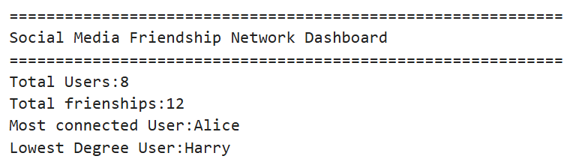
degree_df = pd.DataFrame(
list(degrees.items()),
columns=["User", "Degree"]
)

degree_df = degree_df.sort_values(by="Degree", ascending=False)

plt.figure(figsize=(8, 5))
plt.bar(degree_df["User"], degree_df["Degree"], color="royalblue")
plt.title("Degree Distribution")
plt.xlabel("Users")
plt.ylabel("Degree")
plt.grid(axis="y")
plt.show()
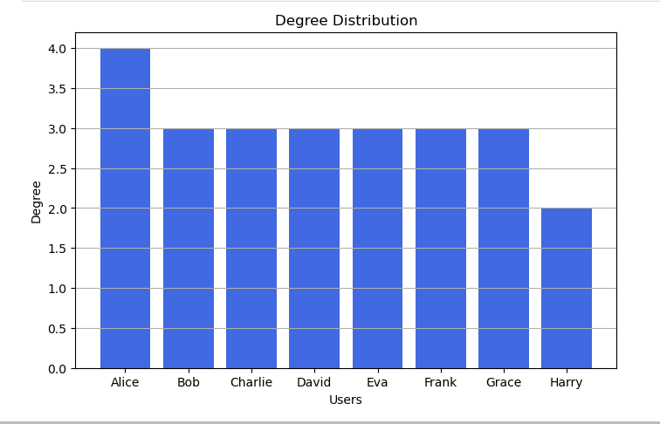

%pip install ipywidgets
import ipywidgets as widgets
from IPython.display import display, clear_output

G = nx.from_pandas_edgelist(df, 'User1', 'User2')

user_dropdown = widgets.Dropdown(
options=list(G.nodes()),
description='User:'
)
output = widgets.Output()

def update(change):
with output:
clear_output(wait=True)
user = user_dropdown.value

print(f"Selected User: {user}")
print("Friends:", list(G.neighbors(user)))
print("Degree:", G.degree(user))

plt.figure(figsize=(6, 4))
pos = nx.spring_layout(G, seed=42)
nx.draw_networkx(G, pos, with_labels=True,
node_color=['red' if n==user else 'skyblue' for n in G.nodes()],
node_size=2500, edge_color='black', width=2)
plt.show()

user_dropdown.observe(update, names='value')
display(user_dropdown, output)
update(None)

